Name: Manish Kumar

Admission Number: 20SCSE1010830

Section 10 Group P1

**Experiment 1**

**Aim**: To understand the use of comment and print command in python using jupyter notebook (Anaconda).

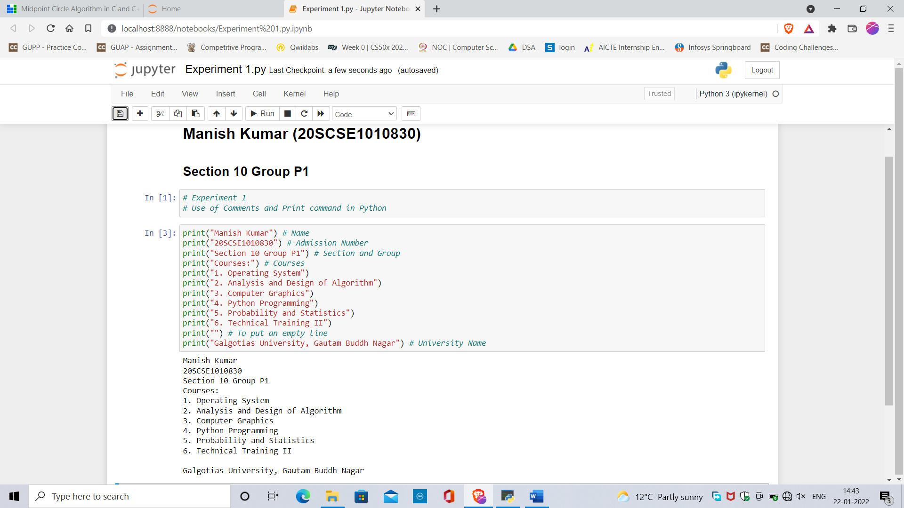

Zoomed in Screen Shot of Output is in next page.

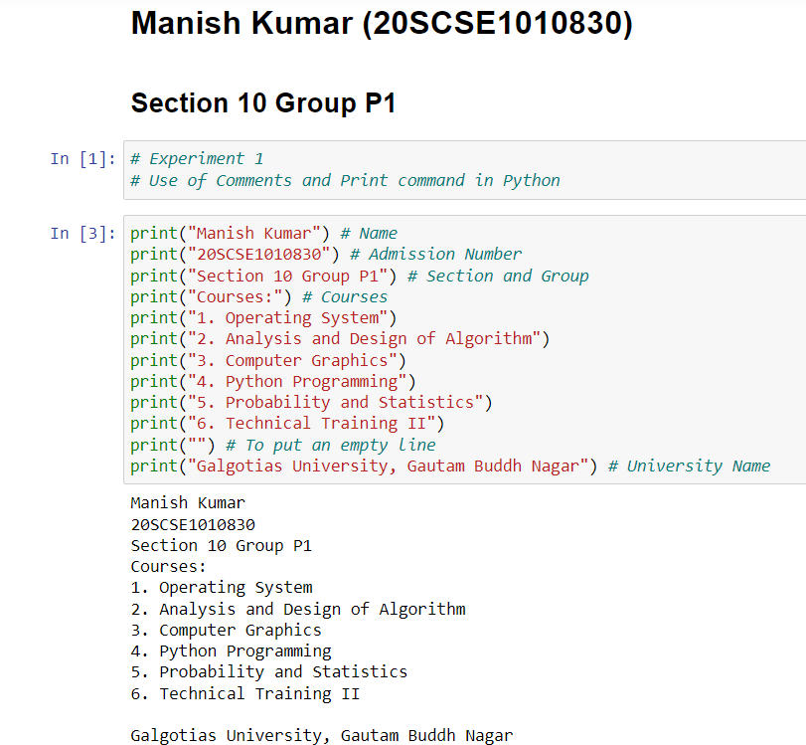

**Conclusion:** Successfully executed the print command and comment concept on jupyter platform